PC KINYANJUI TTI

TVET CDACC PRACTICAL EXAMINATION

TASK 2: TESTING AND DEBUGGING A MOBILE APPLICATION
Candidate Name: Frankline Xavier
Application Name: MyBookCatalog
Class:ICT/L6/MAY/24
Date: 26/06/2026

Testing and Debugging Report

i. Setup Environment
I set up the development environment using Android Studio, Java, Android SDK, and Gradle. I connected an Android emulator and also tested the application on an Android phone.
Result: The development environment was successfully configured.

ii. Conduct Functional Testing
I tested the main features of the application to ensure they were working correctly.
Feature Tested | Result
Opening the application | Passed
Viewing books | Passed
Viewing book details | Passed
Searching books | Passed
Viewing categories | Passed
Adding books to cart | Passed
Viewing profile | Passed

iii. Perform UI/UX Testing
I checked the user interface to ensure that:
- Buttons responded correctly.
- Images displayed properly.
- Text was readable.
- Navigation between screens was smooth.
- The layout fitted different screen sizes.
Result: The user interface was easy to use and responsive.

iv. Device Compatibility Testing
I tested the application on:
- Android Emulator
- Android Smartphone
The application worked successfully on both devices.

v. Debug and Log Tracking
During testing, I used Android Studio Logcat to identify errors. I found issues related to layouts, image resources, RecyclerView, and navigation. I corrected these errors and rebuilt the application successfully.

vi. Fixed Bugs
The following bugs were fixed during testing:
- Corrected XML layout errors.
- Fixed missing drawable images.
- Corrected navigation between screens.
- Fixed RecyclerView not displaying data.
- Changed prices from USD to KSh.
- Fixed the slideshow images.
- Fixed Add to Cart functionality.
- Corrected search functionality.

vii. Document Bugs and Resolutions
Bug Found | Resolution
App failed to build | Corrected XML and Gradle errors.
Images not displaying | Linked the correct images from the drawable folder.
Categories not showing books | Updated the RecyclerView adapter to load all books.
Book details not opening | Corrected the Intent used to open the Book Details page.
Search not working | Implemented search filtering.
Prices showing USD | Changed all prices to Kenyan Shillings (KSh).
Slideshow not displaying | Corrected the ViewPager2 image adapter.
Layout not fitting the screen | Adjusted the layouts using ConstraintLayout and proper margins.

Conclusion
I successfully tested and debugged the MyBookCatalog application. I fixed the identified errors and ensured that the application runs correctly. The Home, Categories, Cart, Profile, Search, Book Details, and Slideshow features work as expected, and the application builds successfully without errors.

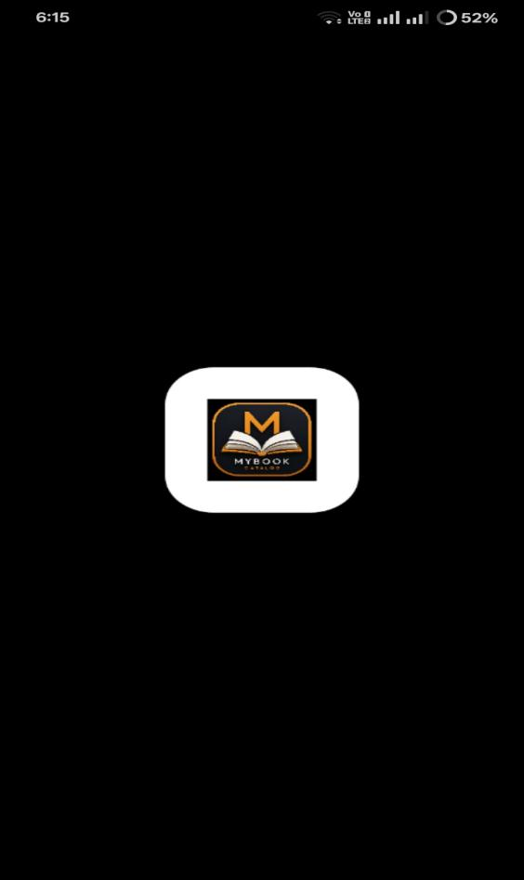
APP ICON

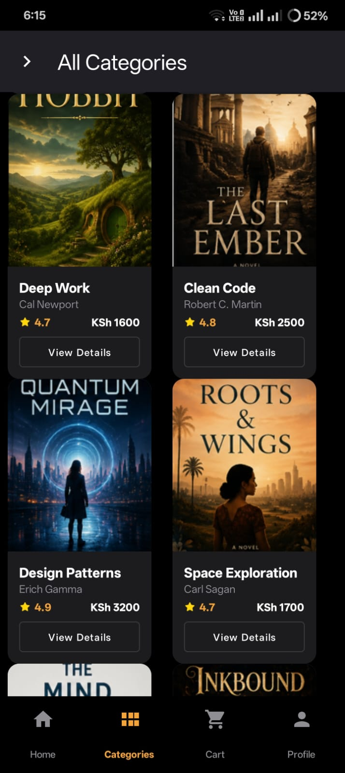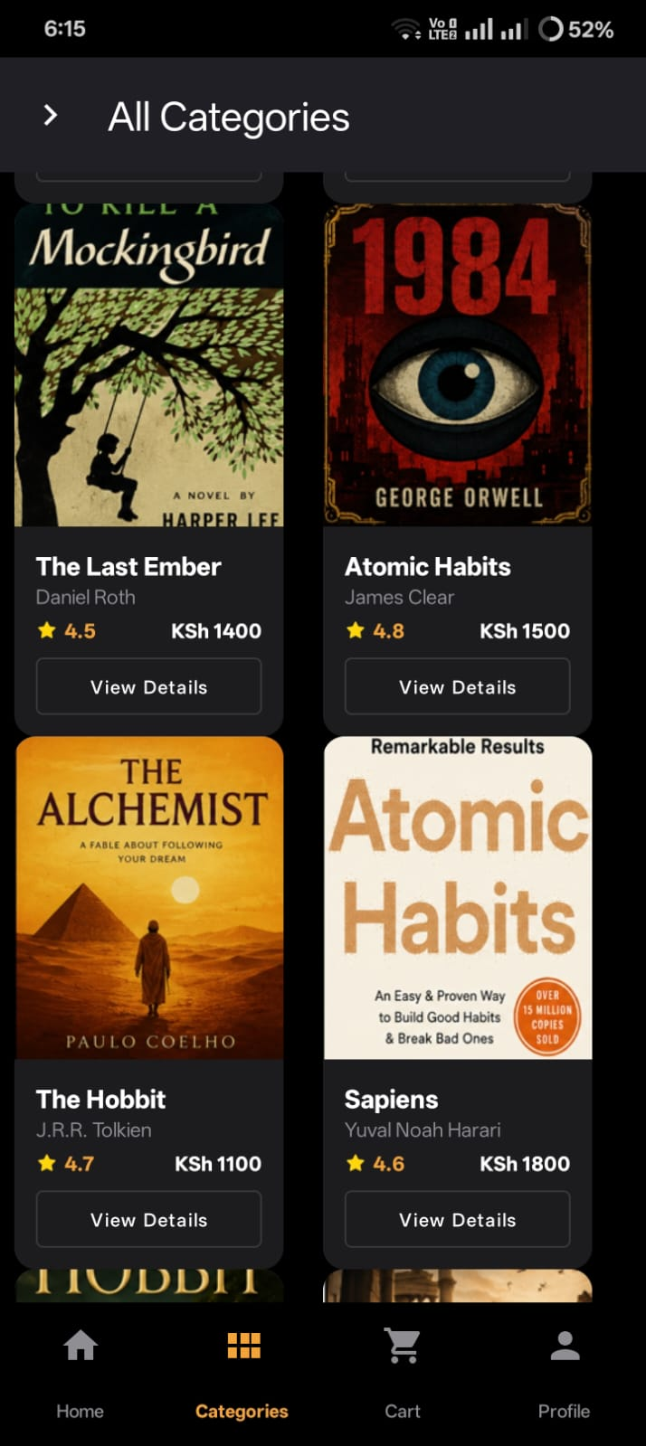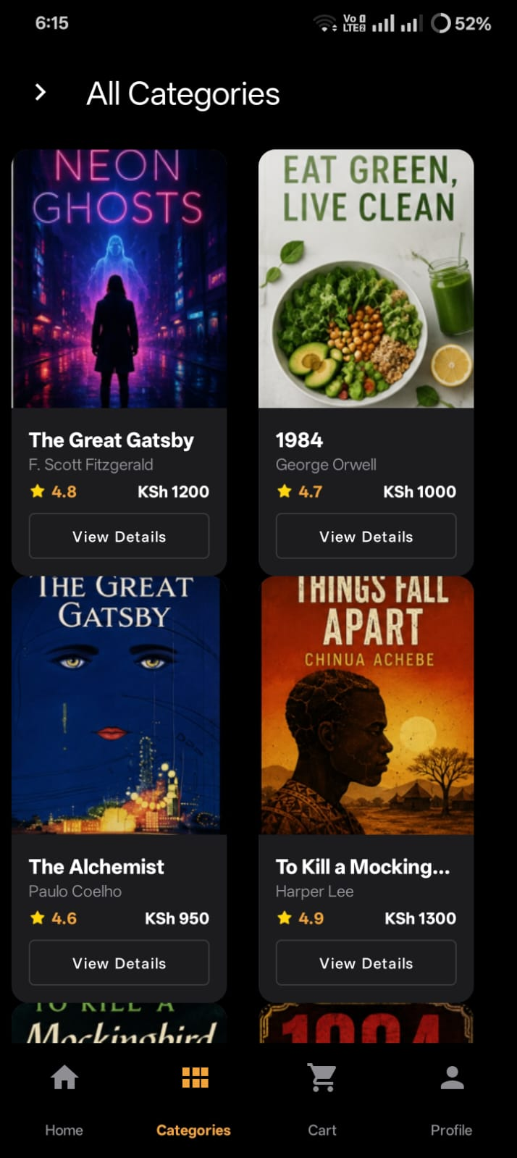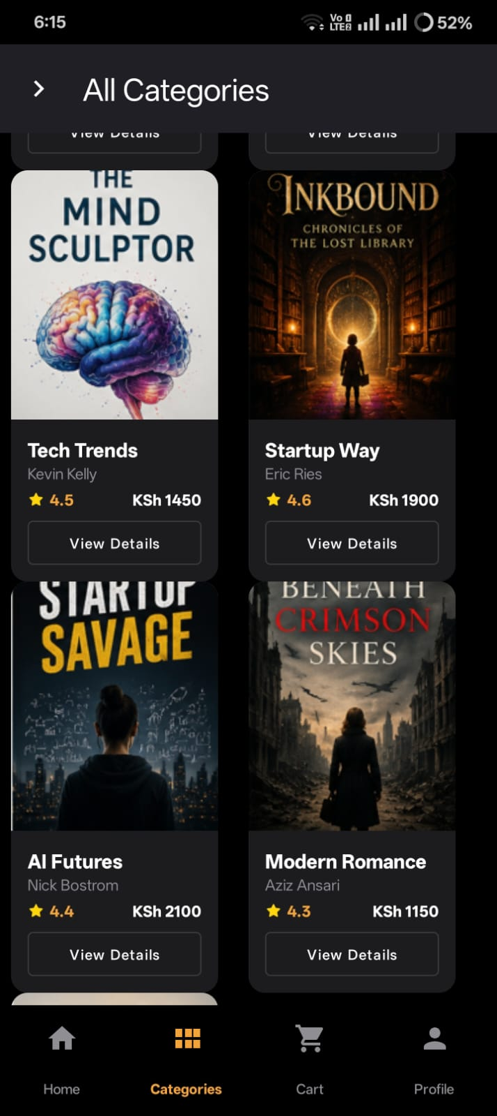
BOOK LIST
